Social Media & Organizational Anticipatory Socialization
NFL
Brendan Nash
CST 350
Dr. Modaff

The National Football League is the largest sports organization in the world. The NFL began in 1920, with 14 professional American football teams, and has since grown to a multi-billion-dollar company, with 32 teams, and games being played all over the world. The NFL is divided equally between two divisions, the American Football Conference, and the National Football Conference. The NFL employs around 3500 individuals, including players, coaches, media specialists, and many other positions within the organization.
I chose to research the NFL for a few reasons. The first being that I am a long-time football fan and player and am interested in diving deeper into their media that I consume daily. I have followed the NFL’s social media for quite some time now, and I have a good understanding of different themes within their posts, and how they use them to connect with their fans. Another reason I chose the NFL is because they post tons of content each day, ranging from reels, stories, articles, news, and even different Netflix series that I thought would be great to analyze.
I focused on the NFL’s Instagram for this report, since they are most active on this platform. Although most of their posts are highlights and statistics from games, there are many posts that highlight the organization’s culture and values. Some common themes I found when analyzing their posts from the past 2 years are family, equal rights, internationality, mental health awareness, and giving back to those in need.
In this report, I will be highlighting the organizational life, communication, relationships, and other aspects regarding organizational socialization within their social media posts and content. I will also be diving deeper into the choices the NFL makes when creating media, and how they may impact us fans.
In the first section of the references appendix, is a post regarding the affects of Hurrican Helene on the Tampa Bay community. This post made by the NFL highlights their commitment to their community, and the culture of family. The way this message was delivered was in a serious manner, during a devastating time in the Tampa Bay community. Viewers of this post came to realize that the NFL is much bigger than football and is willing to help their communities within the organization. This donation and post highlight the NFLs emphasis on community and helping those in need.
In the second section of the references, titled “family,” is a tribute video that tells the story of the 100 years of New York Giants Football. This video features the NFLs values, through history and storytelling. Their family values are reflected within this post by showing generations enjoying Giants football and staying true to their community of 100 years. These values are lived values by the Giants organization and their fans and will continue for as long as football is around.
Football is not just for men. In the women in football section of the references, a star woman flag football player shares her unique journey and ties to the NFL. This post sheds light on the relevant topic of gender roles, especially in a sport that is known for only men to play. The NFL has an entire women’s flag football league, which gives women a chance to participate in a sport they love and prove the public wrong that football is only a man’s support.
In the Netflix Series, “Receiver,” in section 4 of the references appendix, we see a side of the NFL that we do not get to see often. This series takes us through the lives of 4 NFL wide receivers, showing us the difficulties of what it is like being in the NFL. As a viewer of this series, I learned a lot about the culture and life inside of the NFL organization. The culture of the NFL involves a heavy emphasis on family. Each player has a family to provide for, each team is a family, and the NFL is one big family, all striving for a common goal. In our textbook, on page 100, organizational culture is compared to musical performances. The NFL works in a remarkably comparable way to what the book describes. Each player and coach must do their job in symphony, on and off the field, to execute their job as a team. Life in the NFL is very rigorous, between traveling and time away from family, physical and mental challenges, and busy schedules members must work through, it can be hard to have longevity with this organization. This series shows us how NFL players take care of their members with resources such as mental health counseling, physical rehabilitation centers, and many other benefits. This series contributes heavily to the socialization of NFL fans by letting them see the other side of the NFL such as work-life balance, realistic previews of players and coaches’ lives, and some of the ugly sides of being in the NFL.
In the posts featured in the inclusivity section, the NFL is displaying their support of Pride month, and the LGBTQ+ community within the NFL. The NFL highlights inclusivity for all sexualities within their values, and that is on display within these posts. After reading the comment sections of these posts, I found a lot of hate towards their stance on the LGBTQ+ community. Since the gay community in growing amongst active NFL players, it is important they support these individuals no matter what. The NFL is also socializing their community through these posts by showing their support for the LGBTQ+ community, since this issue is very prevalent during this day and age. Their support for this community will allow fans within the gay community to feel safe and enthusiastic about following the NFL and encourage them to feel comfortable in their own sexualities.
The NFL has many players, coaches, and fans from all around the world. In the internationality section of the appendix below, the NFL has many posts about its players from all over the world. This is a particularly important socialization effort towards international fans and players within the league. By showing that they can help people from all over the world come together and play as a team, or cheer together, is helping combat an issue that is much bigger than the NFL. Our world is heavily divided at this time, and the NFL is doing their part to show the world that we can come together and be one big family.
Finally, in the mental health section of the references, we see a powerful post delivered by an NFL player regarding his mental health. Delanie Walker tells us a story about his aunt and uncle who were killed by a drunk driver hours after the Super Bowl he played in. The NFL connected him with an organization called “Mothers Against Drunk Drivers,” which gave him a community to speak with and help him with his mental health. In this post, he highlights how the NFL strives to build strength and connection within their communities, which gives us a glimpse of the NFL’s culture and values. The NFL recognizes that their players are people who struggle with mental health as well and giving them resources and outlets to help them is a notable example of how the NFL cares about their community.
In conclusion, the NFL’s social media team clearly works very hard to socialize their community through their display of values, culture, and life within the organization. Behind the scenes, there is still discrimination, unfairness, & disrespect regarding these topics & communities covered, which questions the realism of these posts from the NFL. It is uncertain whether the NFL is displaying stated values or lived values. However, no organization can be perfect, and the NFL is going in the right direction by publicly showing their support and respect for different communities and issues relevant to our world today. Many see the NFL as a bunch of men bumping heads and fighting for a ball, however, they are much more than that. The NFL is the biggest sports league in the world, and has the power to make positive changes in communities, and influence others to stand up for themselves and fight for what they believe in.

References Appendix
- Community
  - 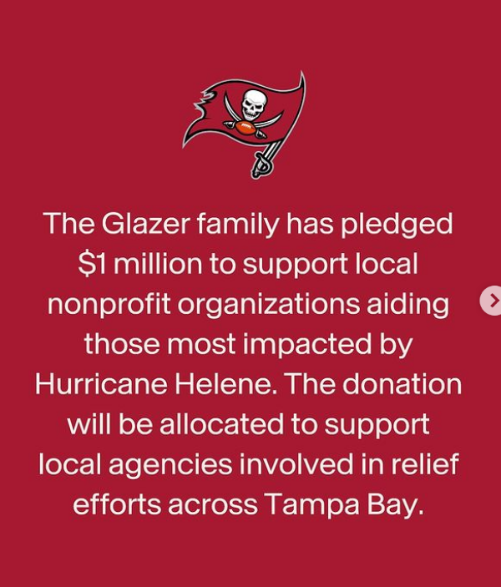
- Family
  - New York Giants | One more week. A forever story. #Giants100 | Instagram
- Women in football
  - NFL | “It brings so many people from all over the world together.” USA National Flag Football WR/S Makena Cook shares what Football Country… | Instagram
- Receiver Series
  - 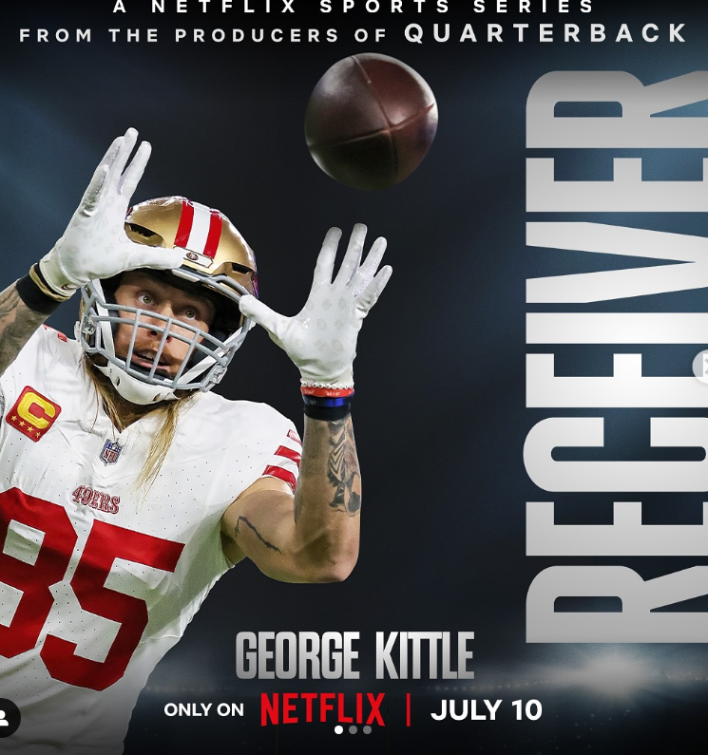
- Inclusivity
  - 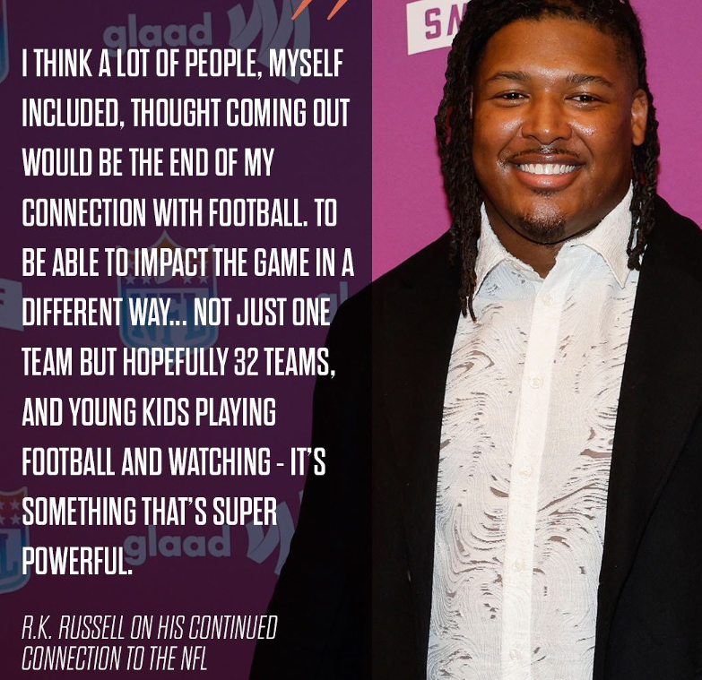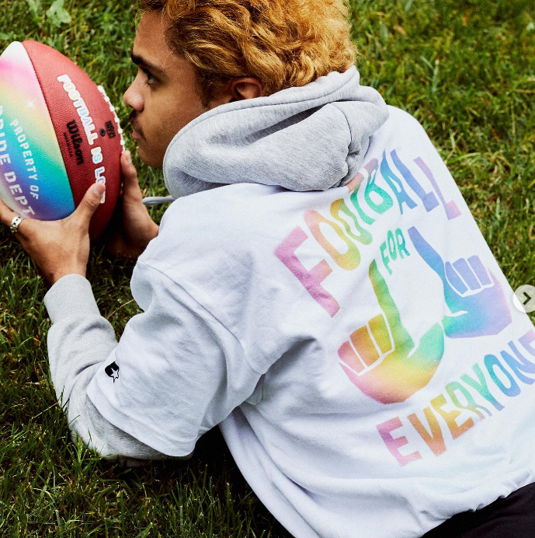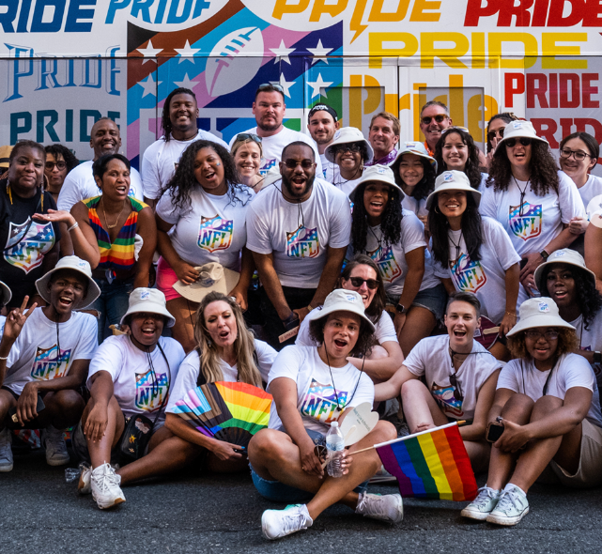
- Internationality
  - 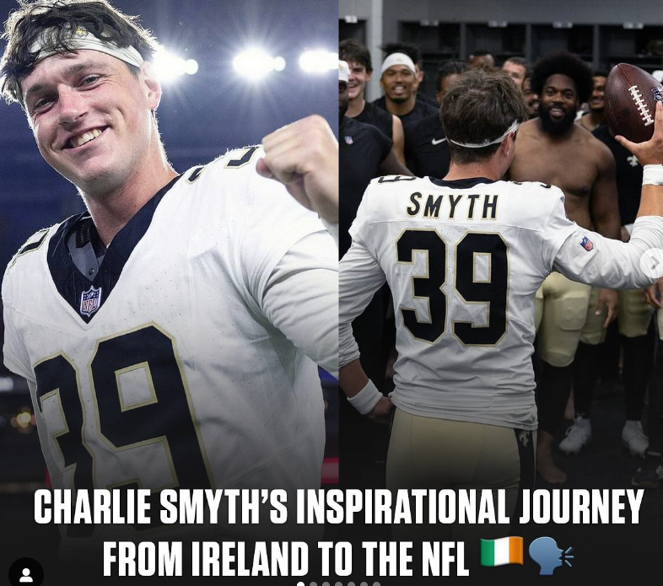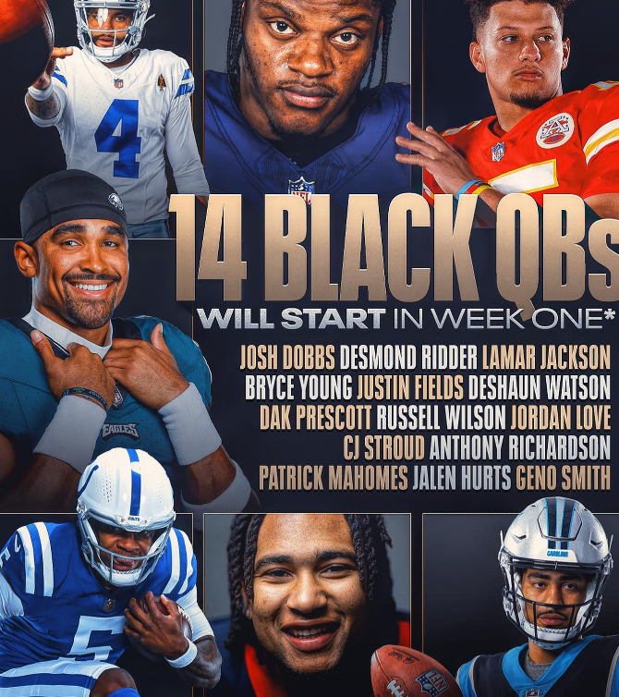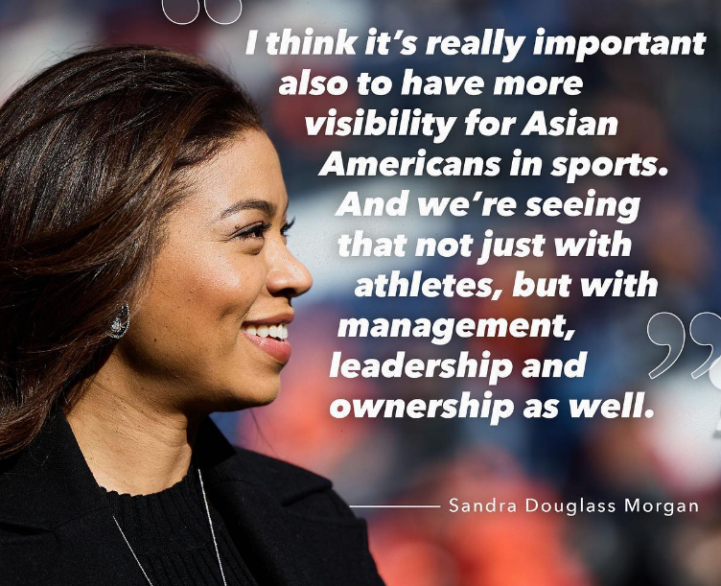
  - 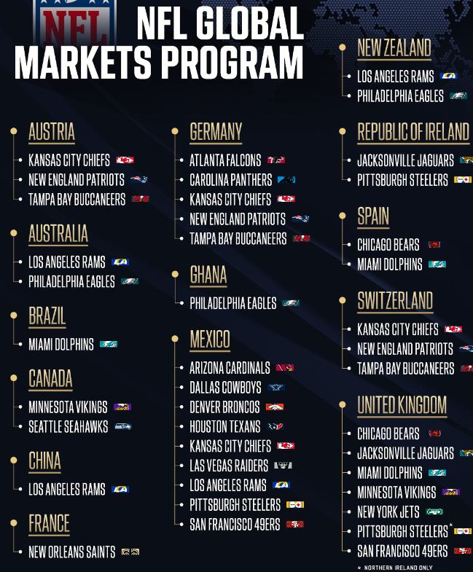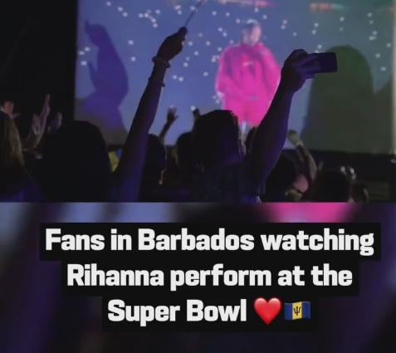
  - Mundo NFL | Family, commitment and effort. Latino icon Fred Warner needed this and more to reach the NFL and fulfill his dream 💭🏈 #PorLaCultura | Instagram
- Mental health
  - NFL Legacy | Delanie Walker shares a personal story on the importance of finding a healthy community & connecting with those who can inspire and uplift… | Instagram

